


Project Quality Plan

Hessay
Project name: Hessay
Document name: Project Quality Plan
Date: 08/06/2026
Author: Harry Crabb
Review by:
Status: Pre-Construction
Revision: 0.1

Contents
1) Purpose and Scope 3
1.1. Quality Policy Implementation 3
1.2. Principles 4
2) Project Summary 5
2.1. Project Scope 5
3) Quality Objectives 6
4) Organisation 6
4.1. Responsibilities 6
4.2. Ethical Power Project Manager 6
4.3. Ethical Power Site Manager 7
4.4. Quality Manager 7
4.5. Site Quality Control Engineer / SHEQ Advisor 8
4.6. Subcontractors 8
4.7. All Project Personnel 9
5) Integrated Management System 9
6) Inspection and Test Plan 9
7) Management of Non-Conformities 10
7.1. Raising an NCR 10
7.2. Notification and Review 10
7.3. Non-conformance categorisation 11
7.4. Non-conformance timescales 11
7.5. Root Cause Analysis and Corrective Action 12
7.6. Close-Out and Verification 12
7.7. NCR Register and Reporting 12
8) Subcontractor and Supplier 12
9) Audit and Continuous Improvement 13
Appendix A – Relevant standards 14
Appendix B – Inspection and Test Plan 15
Appendix C – Non-Conformance documentation templates 16

- Purpose and Scope
This Project Quality Plan has been produced by Ethical Power in support of the Triple Point project Hessay.
The Quality Plan supports and aligns with the Construction Phase Plan (CPP), Project Programme, and Environmental Management Plan (EMP), ensuring the Employer's Requirements set out in the EPC contract are delivered and evidenced.
The Project Quality Plan will:
- Summarise the project quality requirements, where they are located, how they are completed, and who is responsible for them.
- Support the Installation Inspection and Test Plans (ITPs) for the site.
- Record and track any changes made throughout the construction phase.
This Project Quality Plan has been produced to implement the processes and procedures defined within the Ethical Power Quality Management System, which is certified to BS EN ISO 9001:2015.
  - Quality Policy Implementation
Ethical Power is committed to delivering construction services that consistently meet the requirements of its customers and comply with all applicable regulatory and statutory obligations. This commitment is formalised in the Ethical Power Quality Policy (EP-POL-047) and Quality Policy Statement (EP-POL-057), both of which are maintained within the Ethical Power Document Management System and available to all project personnel.

Ethical Power holds certification to BS EN ISO 9001:2015. This Project Quality Plan is the primary mechanism by which the Ethical Power Quality Policy is implemented at project level for Hessay. It defines the specific quality processes, responsibilities, inspection regimes, and document controls that apply throughout the construction phase of this project and takes precedence over general QMS guidance where project-specific requirements are more stringent.

Compliance with the Quality Policy on this project is the responsibility of all personnel. Prior to commencement of works, the Site Manager will ensure that all project personnel are briefed on their obligations under this plan and the wider Quality Policy, with attendance recorded via the site induction process. The Project Manager retains overall accountability for ensuring the policy is upheld and that this plan is reviewed, updated, and communicated throughout the project lifecycle.

  - Principles
Throughout the project, working with our subcontractors will:
- Establish, maintain and continually improve an effective quality management system which complies with the requirements of ISO 9001.
- Put the customer first and collaborate to deliver excellent operational performance.
- Use a process-based approach to ensure consistency and operational excellence.
- Continually improve our quality management system through the regular review of performance.
- Develop and invest in our people so that they can deliver a ‘quality service’ to our customers.
- Record, report and investigate any quality failures.

- Project Summary
Client / Employer | Triple Point
Project Name | Hessay
Project Location | Low Moor Lane, York, YO26 8JT
Local Planning Authority | City of York Council
DNO | Northern Power Grid
Total Installed Capacity | 49.16MW
Declared Net Capacity | 40.00MW
Guaranteed PAC PR%

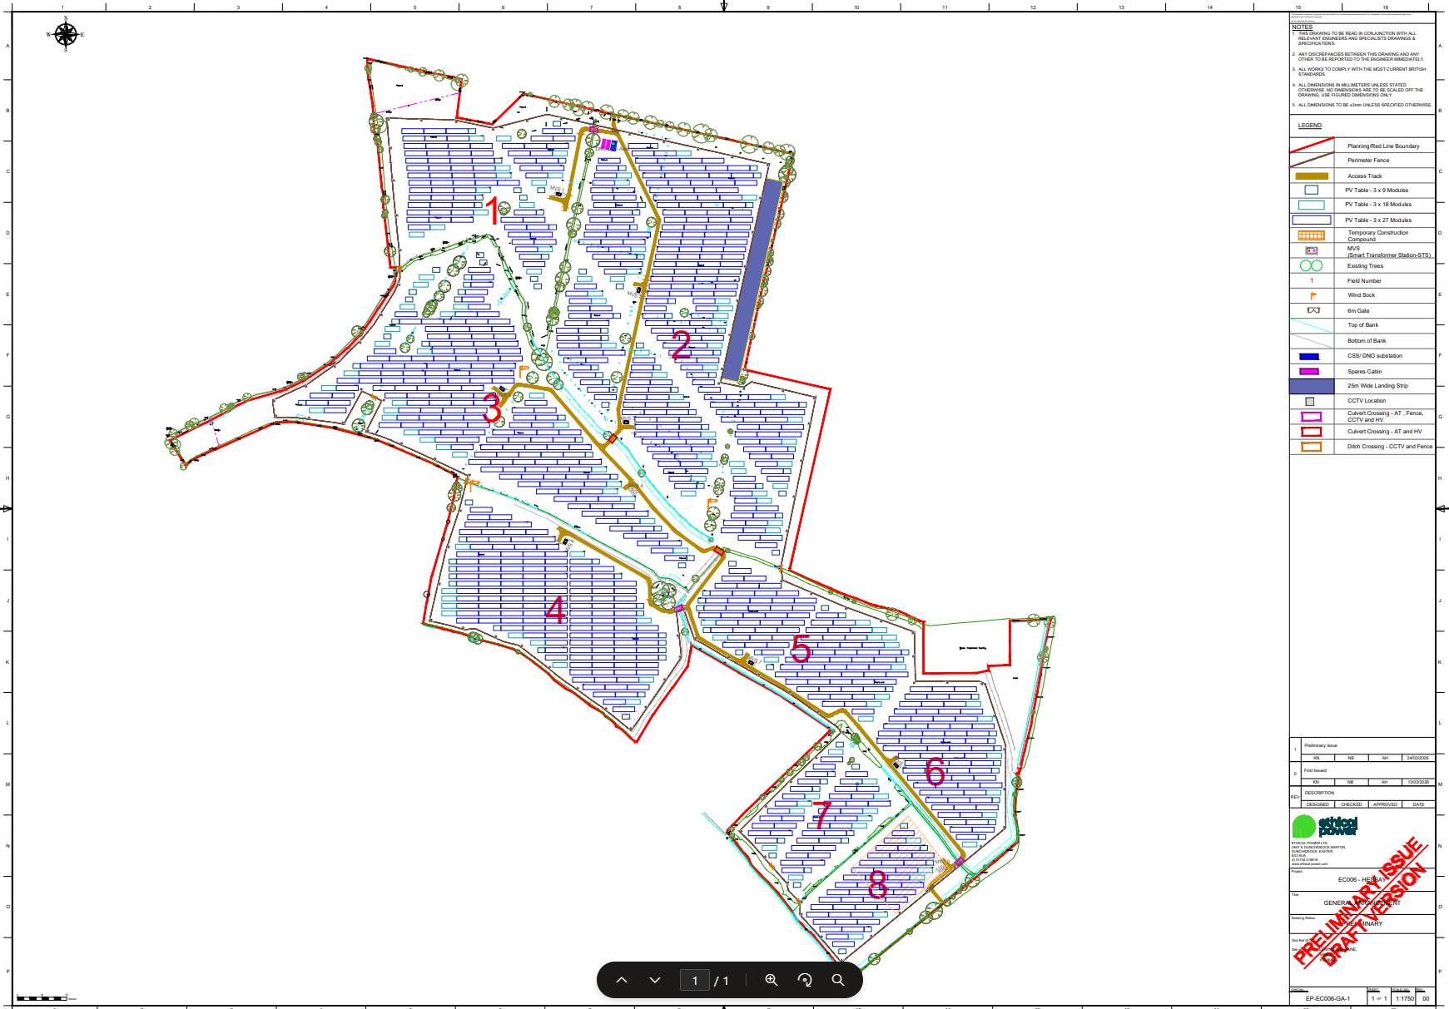

  - Project Scope
Project scope is found in the Hessay EPC contract document and Hessay Employer's Requirements

Ethical Power has been contracted to deliver a full Engineering, Procurement and Construction (EPC) service for the Hessay project. The scope encompasses the complete design, engineering, procurement, and construction of the solar PV installation, including PV modules and mounting structures, all civil works (site access, cable trenching, drainage, fencing, and hardstanding), LV DC and AC electrical systems, MV cabling and transformer stations, earthing, SCADA and meteorological monitoring, and a site-wide security system. Ethical Power holds the Principal Contractor and Principal Designer appointments under CDM 2015 for the duration of the construction phase. The scope extends through to full commissioning, G99 compliance sign-off, DNO acceptance, and formal handover to the Client via the Provisional Acceptance Certificate (PAC) process, including the production of a complete project handover and CDM Health and Safety File.

Quality Objectives:
Ethical Power is committed to establishing, monitoring, and continually improving measurable quality objectives for Hessay in accordance with ISO 9001:2015. These objectives are consistent with the Ethical Power Quality Policy (EP-POL-047) and reflect the Employer's Requirements under the EPC contract.

The objectives shall be communicated to all project personnel pre-commencement and be updated whenever there is a material change to the project scope or programme.

- Right-First-Time Installation philosophy
- Clear non-conformance management and close out timescales
- ITP Hold Point Compliance
- Competence and Induction Compliance
- Material Traceability and Goods-In Compliance
- Defect-Free Handover
- Internal Audit Programme

- Organisation

[Insert project org chart]

  - Responsibilities
The responsibilities defined below apply for the duration of the construction phase. All personnel shall be familiar with this Plan and the documents referenced within it. Any queries regarding quality responsibilities shall be directed to the Quality Manager in the first instance.
  - Ethical Power Project Manager
- Own this Plan and secure Client acceptance prior to commencement of works.
- Maintain overall accountability for compliance with this Plan and all key project control documents throughout the project lifecycle.
- Ensure this Plan is reviewed and revised in consultation with relevant personnel whenever there are material changes to the project programme, scope, or Employer's Requirements.
- Ensure all relevant project documentation is uploaded to the project Document Control system in a timely manner and transmitted to the Client in accordance with the agreed document submission schedule.
- Chair or delegate the chairing of quality review meetings and ensure quality performance is reported via the weekly and monthly project reports.
- Review and approve subcontractor RAMS submissions in conjunction with the Site Manager prior to works commencing.
- Ensure the project-specific quality objectives and KPIs are established at the outset and monitored throughout.
- Ensure the CDM F10 notification is submitted and that Principal Contractor and Principal Designer appointments are in place prior to construction (EP-POL-33, EP-POL-34).
  - Ethical Power Site Manager
- Support the Project Manager in the completion and maintenance of this Plan.
- Ensure day-to-day compliance by all project personnel with the requirements of this Plan and all key project control documents.
- Ensure all site management, supervisory, and subcontractor personnel receive the pre-commencement briefing and site induction before commencing works, with attendance recorded.
- Deliver or arrange Toolbox Talks relevant to quality and workmanship standards at key construction stages, with attendance recorded on.
- Formally appoint the personnel authorised to sign off Hold, Witness, and Notification points on each ITP, and maintain a record of authorised signatories.
- Ensure all Hold Points are released only following a completed and signed inspection, and that no works proceed past a Hold Point without written authorisation.
- Ensure subcontractor RAMS are reviewed and approved prior to works commencing, and that subcontractor compliance with approved RAMS is monitored throughout.
- Ensure material deliveries are inspected at point of receipt against the relevant ITPs and delivery documentation, and that non-conforming or damaged materials are segregated and an NCR raised immediately.
- Escalate any quality issues or NCRs that cannot be resolved at site level to the Project Manager and Quality Manager without delay.
  - Quality Manager
- Support the Project Manager and Site Manager in the production and maintenance of this Plan.
- Ensure all project ITPs are produced, reviewed, and approved prior to the commencement of the relevant works, in accordance with EP_IMS_10 Minimum Requirements.
- Issue ITPs to the Site Quality Control Engineer and relevant subcontractors and confirm that all parties understand their obligations under each ITP prior to works commencing.
- Manage the NCR process — ensuring NCRs are raised correctly, dispositions are agreed, corrective actions are implemented, and close-out evidence is recorded in accordance with EP_IMS_01 and EP_QFC_10.
- Maintain the project non-conformance register and provide NCR status updates in weekly and monthly project reporting.
- Manage and maintain the project calibrated equipment register, ensuring all test equipment holds a valid in-date calibration certificate prior to use and throughout the project, in accordance with EP_QMS_10.
- Plan, schedule, and conduct project-level quality audits and inspections in accordance with EP_IMS_02 and issue audit reports with findings and required corrective actions.
- Monitor and report quality KPIs against the project quality objectives throughout the construction phase.
- Verify that all personnel working on quality-critical activities hold the required competence and certifications.
  - Site Quality Control Engineer / SHEQ Advisor
- Understand and comply with all requirements of this Plan and the project ITPs applicable to their discipline.
- Carry out physical inspections and tests at all designated Hold, Witness, and Notification points as defined in the relevant ITP, recording results clearly and signing off each point only when acceptance criteria have been fully met.
- Raise NCRs on SharePoint immediately upon identification of any nonconforming work or material, ensuring adequate photographic evidence is captured and the relevant area is segregated where required (EP_IMS_01).
- Verify that materials received on site are accompanied by the required documentation, delivery tickets, test certificates, mill certificates, flash test data and that records are uploaded to the project EDMS without delay.
- Ensure that all calibrated test equipment used on site holds a current in-date calibration certificate before use, and report any out-of-tolerance or expired equipment to the Quality Manager immediately (EP_QMS_10).
- Support the Quality Manager during audits and any Client quality surveillance visits.
  - Subcontractors
- Comply fully with this Plan, the relevant project ITPs, and all Ethical Power quality procedures applicable to their scope of works.
- Produce and submit RAMS for review and approval by Ethical Power prior to commencing any works on site.
- Attend the pre-commencement briefing and site induction before starting works and ensure all their operatives complete the site induction.
- Notify the Site Quality Control Engineer or Site Manager in advance of all Hold and Witness Points in accordance with the notice periods defined in section 7 of this Plan.
- Ensure that all personnel deployed on quality-critical or competence-controlled activities hold the required qualifications, certifications, and authorisations, and provide evidence to the Quality Manager on request.
- Co-operate fully with Ethical Power and Client quality inspections and audits.

  - All Project Personnel
- Read, understand, and comply with all requirements of this Plan and the project control documents applicable to their role and scope of work.
- Complete the Ethical Power site induction and any role-specific briefings before commencing works.
- Report any quality concerns, nonconformities, or near misses to their line supervisor or the Site Quality Control Engineer immediately.
- Never proceed past a designated Hold Point without confirmed written sign-off.

- Integrated Management System
Ethical Power operates an integrated Quality Management System (QMS) certified to BS EN ISO 9001:2015. The QMS is governed by the EP_QMS_01 QMS Manual and underpinned by the EP-POL-047 Quality Policy and EP-POL-057 Quality Policy Statement, both of which are available to all project personnel. The current issue of all Ethical Power management processes, procedures, and associated forms is maintained on the Ethical Power SharePoint system. All personnel engaged on this project are required to be familiar with their obligations under the relevant processes. Any printed copy of a controlled document shall be treated as uncontrolled; the SharePoint-held version constitutes the controlled master.

- Inspection and Test Plan
Inspection and Test Plans (ITPs) shall be compiled for all elements of the works, covering civil, structural, mechanical, and electrical installation activities, and for the delivery and acceptance of major plant and equipment items. The detailed minimum content requirements for all ITPs are defined in EP_IMS_10 Minimum Requirements, which shall be read in conjunction with this section. ITPs shall be produced by the relevant subcontractor or Ethical Power site team prior to the commencement of each relevant package of works and submitted for review and approval in accordance with the document control process.
Each ITP shall define inspection and test activities against three categories of control point, as follows:

- Hold Point (H): Work shall not proceed beyond this point until the inspection or test has been carried out and formally signed off by the designated responsible party. A minimum of 48 hours' written notice shall be given prior to a Hold Point inspection. No Hold Point may be released without an authorised signature.
- Witness Point (W): The designated party shall be notified and given a minimum of 24 hours' notice to attend. Works may proceed if the notified party does not attend within the agreed timeframe, provided notification is documented.
- Test Point (T): Specific testing is to take place outside of the standard inspection test document (ITD) / Checklist.

The responsible parties for each control point, whether Ethical Power, the Client, the subcontractor, or a third-party inspector, shall be identified within the ITP prior to issue.
Where an inspection or test result does not meet the specified acceptance criteria, work shall not proceed and a Non-Conformance Report (NCR) shall be raised in accordance with EP_IMS_01 Control of Nonconformity and EP_QFC_10. The NCR shall be resolved, and the inspection point re-examined before the ITP activity is signed off and works continue.

Completed and signed ITP records, together with all associated test certificates, calibration records, and material traceability documentation, shall be maintained in the project document management system and shall form part of the project commissioning folder and final handover documents.

- Management of Non-Conformities
Ethical Power operates a formal Non-Conformance Reporting (NCR) process in accordance with EP_IMS_01 Control of Nonconformity and EP_QFC_10, ensuring that all nonconforming work, materials, or processes are identified, controlled, and resolved in a timely and documented manner. No nonconforming work shall be concealed, incorporated, or permitted to proceed without a recorded disposition and authorised sign-off.
  - Raising an NCR
NCRs shall be raised on the Ethical Power SharePoint NCR system via the MS Forms link, accessible through the QR code displayed on site NCR posters and within the NCR guidance documentation available in the Ethical Power IMS. The QR code for this project is included in Appendix C. Any member of the project team; including subcontractor personnel may and is expected to raise an NCR upon identification of a nonconformity. NCRs shall be raised at the point of identification; they shall not be deferred or informally resolved before being logged.
Each NCR submission shall capture, as a minimum, the following information:

- Project name and site reference
- Date and time of identification
- Location on site / work package reference
- Description of the nonconformity, including relevant specification or ITP clause
- Photographic evidence
- Subcontractor or supplier involved, where applicable
- Immediate containment action taken
  - Notification and Review
On submission, the NCR will be automatically logged to the project NCR register on SharePoint and the Site Quality Control Engineer and Quality Manager will be notified for review. The Site Manager shall be informed of any NCR with potential programme or safety implications without delay.
The Quality Manager, in consultation with the Site Manager and relevant engineering resource, shall determine the appropriate actions for each NCR.

  - Non-conformance categorisation
Minor NC
A standard Nonconformity, where something has deviated from specification or
procedure/process. This should be targeted for correction as soon as possible so
that it does not progress into a bigger issue. Multiple instances of the same minor
NC may upgrade the fault to a major
Major NC
A Major NC is a total disregard for the procedure/process and responsibility, or
where the product has failed catastrophically, and may have the ability to
cause further issues/NCs or injury. If a minor NC is being repeated and attempts
to address the cause/root cause are having no effect, it can be upgraded to a
Major.
An 8D report, is available with additional investigation analysis and tools
in the event of a Major NC or where customer requirement dictates an 8D must
be raised.

  - Non-conformance timescales
Requirement | Expectation
NCR raised | Within 24 hours of detection
Root cause analysis completed | Within 5 working days
Corrective action implemented | Within 10 working days or agreed timeline
Closure verified | QA/QC Manager or Client Representative sign-off
NCR log updated | Weekly review minimum
Trend analysis | Monthly quality meeting

  - Root Cause Analysis and Corrective Action
For all NCRs, a root cause shall be identified and a corrective action defined to prevent recurrence. The depth of root cause analysis shall be proportionate to the severity and recurrence of the nonconformity. Corrective actions shall be assigned to a named owner with a defined completion date and recorded within the NCR record on SharePoint.
  - Close-Out and Verification
NCRs shall only be closed once the agreed corrective action has been fully implemented and verified by the Site Quality Control Engineer or Quality Manager. Objective evidence of close-out: photographs, re-test results, revised documentation. Shall be attached to the NCR record before closure.
  - NCR Register and Reporting
The project NCR register shall be maintained on the Ethical Power SharePoint system throughout the construction phase, providing a live record of all open, in-progress, and closed NCRs.

- Subcontractor and Supplier
Ethical Power operates a formal supplier and subcontractor pre-qualification questionnaire (PQQ) process to verify the competency, suitability and quality capability of all suppliers and subcontractors prior to engagement. Only those meeting our approval criteria are added to the approved supplier/subcontractor register. This pre-qualification and approval process aligns with the controls required under ISO 9001:2015 (Control of externally provided processes, products and services). Quality obligations are formally passed down through subcontract documentation and include the submission of Inspection and Test Plans, compliance with the project NCR process, provision of inspection and hold/witness point notifications, and adherence to all applicable specifications and standards. Subcontractor ITPs and method statements are reviewed and approved by the Project Quality Manager prior to commencement of works, with hold and witness points confirmed and any comments closed out before approval is granted. Ongoing surveillance and oversight is maintained through a programme of planned audits, routine site inspections, and attendance at agreed hold/witness points, with frequency determined by the criticality of the activity and the ITP Material and equipment traceability is required throughout, with subcontractors obligated to provide batch records, mill/test certificates, delivery documentation and evidence of CE/UKCA marking, ensuring all materials are verified as compliant and traceable to the works in which they are installed.

- Audit and Continuous Improvement
Outlined within EP_POL_047. Internal management System audits are conducted against an agreed audit programme to determine whether the documented Integrated Management System continues to conform to planned arrangements and whether these arrangements are effectively implemented across the relevant area of the company.

Site quality audits are conducted on a planned, risk-based schedule to verify that project activities, processes and documentation conform to the project quality plan, contractual requirements and ISO 9001:2015. Audit findings, observations and opportunities for improvement are recorded, trended and reviewed by management, feeding directly into corrective actions and the continual improvement of our quality management system.

Non-Conformance Reports (NCRs) capture instances where works, materials or processes fail to meet specified requirements, ensuring each is controlled, investigated and resolved through appropriate corrective action. NCR data is logged, trended and analysed to identify recurring issues and root causes, enabling preventive measures that reduce repeat occurrences and drive continuous improvement.

Appendix A – Relevant standards
Codes and Standard
Contractor shall perform the Work and deliver the Work in accordance with the Codes and Standards set forth in this section and in compliance with all other parts of the Contract.
The applicable regulations, standards and laws which are mentioned within this document, are to be regarded as non-exhaustive and do not relieve the Contractor from its obligation to provide complete and fully functional systems and facilities. The Contractor shall observe all the applicable laws, national and international standards which are relevant for completion of its Work under the Contract.

When a specific topic is not regulated by a national law or standard, the Work shall comply with the standards issued by the following organisations, in order of precedence:
Association national standards, for example:
- BSI: British Standards Institution;
- UBC/IBC: Universal/International Building Code;
- International standards:
- IEC: International Electrotechnical Commission;
- UL: Underwriters Laboratories;
- ISO: International Organisation for Standardisation; and
- IEEE: Institute of Electrical and Electronic Engineers.
- In the absence of any relevant association national standards or international standards, EN European Standards shall be used.

Specific PV standards affecting to the components of each Facility are described in detail in the respective Technology Specific ERs.

- Statutory Regulations / Requirements
All parts of the Contractor’s responsibilities including but not limited to design, management, installation, procurement and component supply, testing and commissioning must comply with the following non-exhaustive list of statutory requirements:
- Connection and Use of System Code (CUSC);
- BS7671, IEC 60364, Low voltage electrical installations and HV systems;
- Health and Safety at Work act 1974;
- Management of Health and Safety at Work Regulations;
- Environmental Protection Act 1990;
- Distribution Code;
- Building codes such as BS 5950 structural design;
- BS 9999: Fire Safety in the Design, Management, and Use of Buildings;
- The Environment Act 2021, covering waterways and environmental impacts of construction and waste management;
- National Building Codes and Construction regulations, including CDM;
- National Fire Prevention regulations;
- Products certifications according to the national and international standards made by independent accredited laboratories; and
- All relevant standards referred to in this document and appendices.
- General Standards
- ISO 9001:2015, Quality management;
- ISO 14001:2015, Environmental management; and
- OHSAS 18001:2007 Occupational Health and Safety Management or ISO 45001: 2018.
- Power Transformers
- IEC 60076, Power transformers (parts as relevant);
- IEC 61378-1:2011, Converter transformers - Transformers for industrial applications;
- IEC 61099, Insulating liquids - Specifications for unused synthetic organic esters for electrical purposes;
- IEC 60296:2012, Fluids for electrotechnical applications - Unused mineral insulating oils for transformers and switchgear;
- IEC 60422: 2013, Mineral insulating oils in electrical equipment - Supervision and maintenance guidance;
- IEC 60599:2015, Mineral oil-filled electrical equipment in service – Guidance on the interpretation of dissolved and free gases analysis;
- IEC 60270, High-voltage test techniques - Partial discharge measurements; and
- IEC 60156, Insulating liquids - Determination of the breakdown voltage at power frequency - Test method.
- Electrical Equipment
- Overhead Power Lines
The design and construction shall be carried out in compliance with the applicable Standards, including, but not limited to, the following which, for avoidance of doubt, shall be superseded by the requirements of the DNO where applicable:
- EN 50341 (all parts), Overhead electrical lines exceeding AC 1 KV;
- IEC 60826:2017, Design criteria of overhead transmission lines;
- IEC 60038:2009, IEC standard voltages;
- IEC 60652:2002, Loading tests on overhead line structures;
- IEC 60060:2018 SER, High-voltage test techniques – ALL PARTS;
- IEC 60071:2018 SER, Insulation coordination – ALL PARTS;
- IEC 61773:1996, Overhead lines - Testing of foundations for structures;
- IEC TS 61774:1997, Overhead lines - Meteorological data for assessing climatic loads;
- IEC 61854:1998, Overhead lines - Requirements and tests for spacers;
- IEC 61284:1997, Overhead lines - Requirements and tests for fittings;
- IEC 61865:2001, Overhead lines - Calculation of the electrical component of distance between live parts and obstacles - Method of calculation;
- IEC 61897:1998, Overhead lines - Requirements and tests for Stockbridge type aeolian vibration dampers;
- IEC TR 61597:1995, Overhead electrical conductors - Calculation methods for stranded bare conductors;
- IEC 61395:1998, Overhead electrical conductors - Creep test procedures for stranded conductors;
- IEC 61089:1991, Round wire concentric lay overhead electrical stranded conductors;
- IEC 60305:1995, Insulators for overhead lines with a nominal voltage above 1000 V - Ceramic or glass insulator units for AC systems - Characteristics of insulator units of the cap and pin type;
- IEC 60383 (all parts), Insulators for overhead lines with a nominal voltage above 1000 V;
- IEC 60433:1998, Insulators for overhead lines with a nominal voltage above 1000 V - Ceramic insulators for AC systems - Characteristics of insulator units of the long rod type;
- IEC 60720:1981, Characteristics of line post insulators;
- IEC TS 60815 (part 2 or 3 as relevant), Selection and dimensioning of high-voltage insulators intended for use in polluted conditions; and
- IEC 61109:2008, Insulators for overhead lines - Composite suspension and tension insulators for AC systems with a nominal voltage greater than 1 000 V - Definitions, test methods and acceptance criteria.
- General
- IEC 61869, Instrument Transformers (parts as relevant);
- IEC 60287-1, Electric cables - Calculation of the current rating;
- IEC 60228:2004, Conductors of insulated cables;
- IEC 60332-1-2:2004, Tests on electric and optical fibre cables under fire conditions - Part 1-2: Test for vertical flame propagation for a single insulated wire or cable - Procedure for 1 kW pre-mixed flame;
- IEC 61034 (all parts), Measurement of smoke density of cables burning under defined conditions;
- IEC 60068-2-78:2012, Environmental testing – Part 2-78: Tests. Test Cab: Damp heat, steady state;
- IEC 60754-1:2011, Test on gases evolved during combustion of materials from cables - Part 1: Determination of the halogen acid gas content;
- IEC 60811-100:2012, Electric and optical fibre cables - Test methods for non-metallic materials - Part 100: General;
- IEC 62444:2010, Cable Glands for electrical installations; and
- IEC 60216-1:2013, Electrical insulating materials - Thermal endurance properties - Part 1: Ageing procedures and evaluation of test results.
- Low Voltage
- BS7671:2018;
- IEC 60364 (all parts), Low-Voltage electrical installations (for topics not included in National Electrical Standards);
- IEC62446: Photovoltaic (PV) systems – Requirements for testing, documentation and maintenance;
- IEC 61439 (all parts), Low-voltage switchgear and control gear assemblies;
- IEC 60947, Low-voltage switchgear and control gear (parts as relevant);
- IEC 60269 (all parts), Low-voltage fuses;
- IEC 60227 (all parts) Polyvinyl chloride insulated cables of rated voltages up to and including 450/750V;
- IEC 60245 (all parts), Rubber insulated cables - Rated voltages up to and including 450/750V;
- IEC 62852:2014, Connectors for photovoltaic systems. Safety requirements and tests;
- IEC 60189-1:2018, Low frequency cables and wires with PVC insulation and PVC sheath – Part 1: General test and measuring methods;
- TUV 2 Pfg 1169 08.2007 – Requirements for cables for use in photovoltaic-systems;
- IEC 60898-1:2015, Electrical accessories - Circuit-breakers for overcurrent protection for household and similar installations - Part 1: Circuit-breakers for AC operation; and
- IEC 60715:2017 Dimensions of low-voltage switchgear and control gear. Standardized mounting on rails for mechanical support of electrical devices in switchgear and control gear installations.
- High Voltage
- IEC 62271, High-voltage switchgear and control gear (parts below as relevant);
- -1, Common specifications for alternating current switchgear and control gear;
- -100, Alternating current circuit-breakers;
- -110, Inductive load switching;
- -200, AC metal-enclosed switchgear and controlgear for rated voltages above 1 kV and up to and including 52 kV;
- -202, High-voltage/ low-voltage prefabricated substation;
- IEC 60502:2018 SER Power cables with extruded insulation and their accessories for rated voltages from 1 kV (Um = 1,2 kV) up to 30 kV (Um = 36 kV) – ALL PARTS;
- IEC 62271-204:2011, High-voltage switchgear and controlgear - Part 204: Rigid gas-insulated transmission lines for rated voltage above 52 kV;
- IEC 60840:2011, Power cables with extruded insulation and their accessories for rated voltages above 30kV;
- IEC 60183:2015, Guidance for the selection of high-voltage A.C. cable systems; and
- IEC 60840:2011, Power cables with extruded insulation and their accessories for rated voltage above 30kV (Um=36kV) up to 150kV (Um=170kV) – Test methods and requirements.
- Cable Containment, Trenches and Ducting
- IEC 60364-5 (all sections), Selection and erection of electrical equipment;
- IEC 61386-24:2004, Conduit systems for cable management - Part 24: Particular requirements - Conduit systems buried underground;
- IEC 61386-21:2002, Conduit systems for cable management - Part 21: Particular requirements - Rigid conduit systems; and
- IEC 61084:2017 (all parts), Cable trunking and ducting systems for electrical installations.
- Cable Jointing and Terminations
- IEC 61442:2005 Test methods for accessories for power cables;
- EN 61238-1:2003 Compression and mechanical connectors for power cables;
- IEC 61914:2015 Cable cleats for electrical installations;
- IEC 60947-7-2:2009 Low voltage switchgear and control gear – part 7-2: Ancillary equipment –Protective conductor terminal block for copper conductors; and
- IEC 60502 Power cables with extruded insulation and their accessories for rated voltages from 1 kV (Um = 1,2 kV) up to 30 kV (Um = 36 kV).
- Security System
- IEC 62676-4:2014, Video surveillance systems for use in security applications. Application guidelines; and
- IEC 60839 (all parts), Alarm and electronic security systems.
- Monitoring System
- ISO 9060:1990 Solar energy - Specification and classification of instruments for measuring hemispherical solar and direct solar radiation;
- IEC 61853-1:2011, Photovoltaic (PV) module performance testing and energy rating - Part 1: Irradiance and temperature performance measurements and power rating
- IEC 61724-1:2017, Photovoltaic system performance – Monitoring;
- IEC 61850 (all parts) - Communication networks and systems for power utility automation;
- IEC 60870-6-503:2014, Telecontrol equipment and systems - Part 6-503: Telecontrol protocols compatible with ISO standards and ITU-T recommendations - TASE.2 Services and protocol;
- IEC 61000-6-1:2016, Electromagnetic compatibility (EMC) - Part 6-1: Generic standards - Immunity for residential, commercial and light-industrial environments;
- IEC 61158 (all parts), Industrial communication networks – Fieldbus specifications;
- ISO/IEC 11801, Information technology – Generic cabling for customer premises;
- IEC 61784 (all parts), Industrial communication networks – Profiles;
- IEC 61918:2018, Industrial communication networks – Installation of communication networks in industrial premises;
- IEC 81346 (all parts), Industrial systems, installations and equipment and industrial products - Structuring principles and reference designations;
- IEC 60870-5:2018 SER, Telecontrol equipment and systems - Part 5: Transmission protocols - ALL PARTS; and
- IEC 62443, Industrial Automation and Control Systems Security.
- Metering
- National Metering regulations;
- IEC 62052 (all parts), Electricity metering equipment (AC) - General requirements, tests and test conditions.
- Mechanical, Civil and Structural Design Standards
- National Building Code and Construction regulations;
- IEC 60826:2003 Design criteria of overhead transmission lines;
- IEC 61773:1996 Overhead lines – testing of foundations for structures; and
- IEC 60364-7-704:2005 Low-voltage electrical installations: Construction and demolition sit installations.

Appendix B – Inspection and Test Plan
[To be produced]

Appendix C – Non-Conformance documentation templates
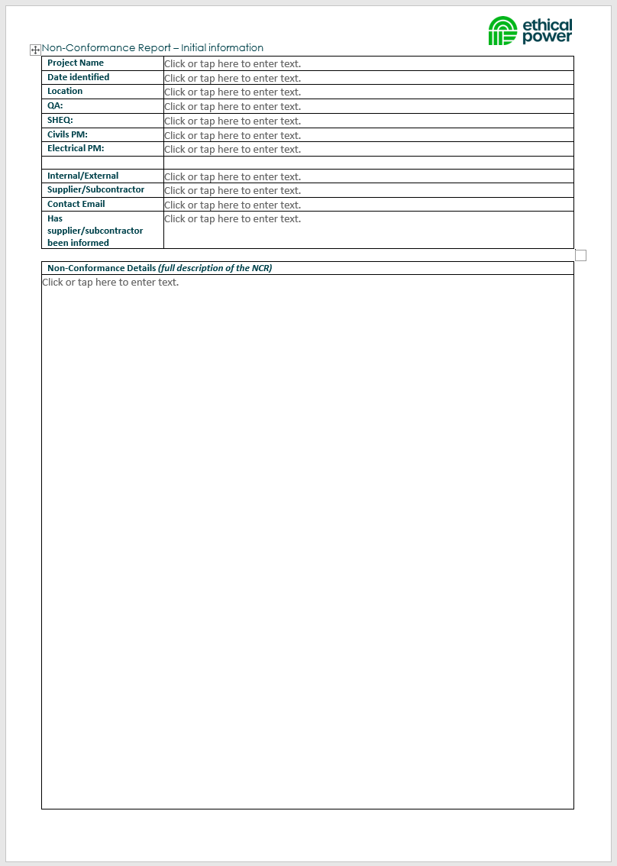

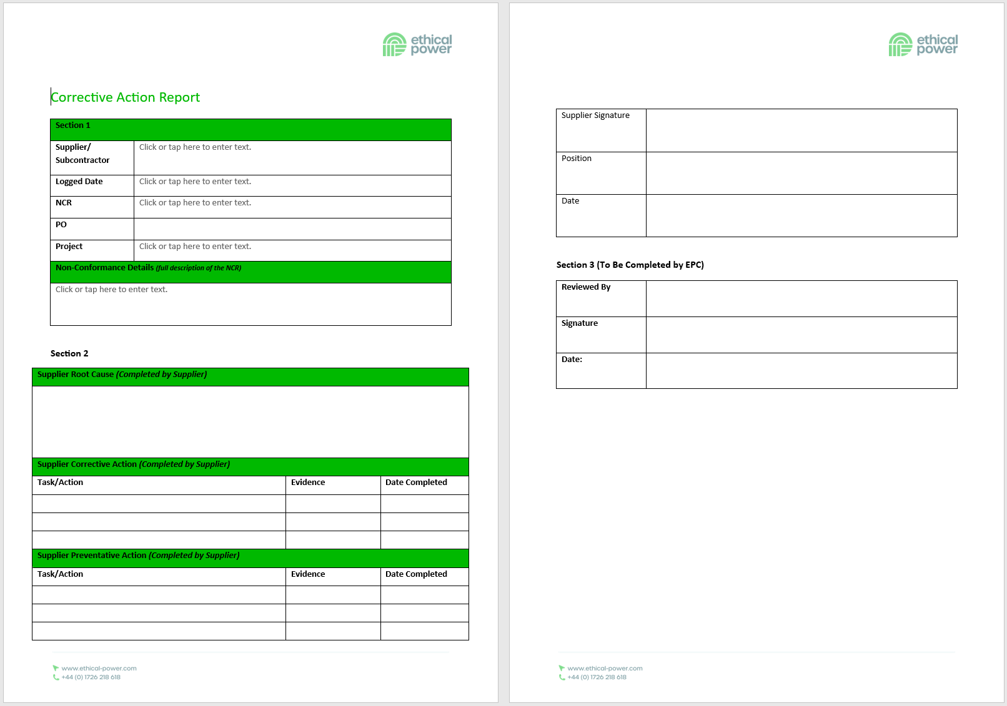

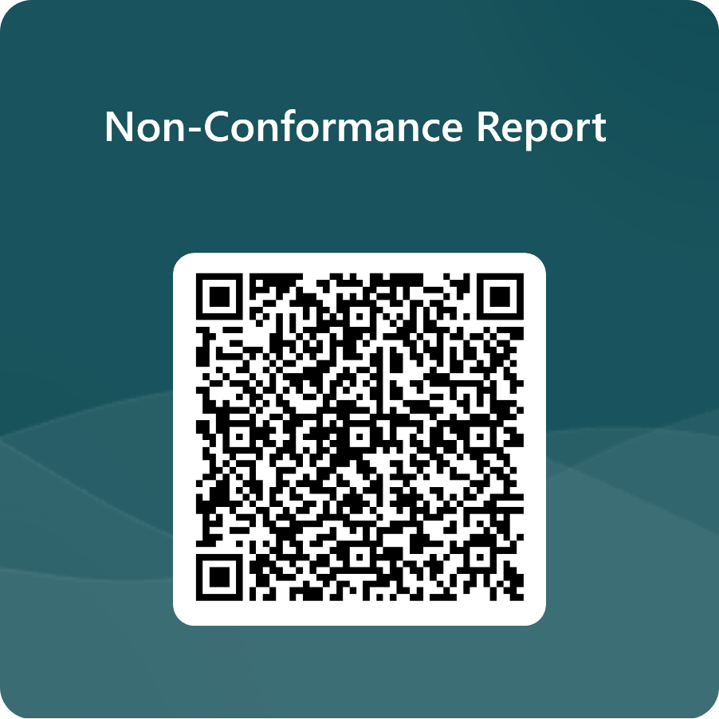



Telephone
01726 218 618
Website
www.ethical-power.com
Address
Ethical Power
Unit 9, Dunchideock Barton
Dunchideock, Exeter
United Kingdom
EX2 9UA

